Introduction of Computer
The word computer has come from the word “compute” which means to calculate.
Computer is an electronic device, which accepts and stores data, processes them and produce the output under the given direction.
Parts of Computer
Computer generally divided into two parts.
1) HARDWARE 2) SOFTWARE
1) Hardware: The physical components of computer system are called Hardware. It is four parts-
1) CPU
2) Input Device
3) Storing Device or Memory
4) Output device
1) Central Processing Unit (CPU): The Central Processing Unit is the most important hardware component of computer system. It is also known as CPU. It is Brain of computer. All type of works in the computer is being done by the CPU. There are two components of CPU 1) Arithmetic Logic Unit (ALU) 2) Control Unit.
Inside a CPU there are-
- Motherboard b) Ports C) SMPS (Switch Mode Power Supply) d) Micro Processor e) Sound Card f) Video Card g) Hdd h) RAM i) ROM
2) Input Device: The Device through which a user can give instruction is called Input Device.
Example: Keyboard, Mouse, Scanner, Light Pen, Joystick, Digital Camera, Web Camera, Touch Pad, Touch Screen, Modem etc.
3) Storing device & Memory: These are the device, which help us to store data and information into machine. Memory is two types –
a) Primary Memory: The Memory, which is necessary to start – up the computer system. In this type of Memory we can only work with data and information.
It is two types-
- ROM: ROM means Read Only Memory i.e. we can read the stored information from ROM, if required but you cannot write any new information to it.
- RAM: RAM means Random Access Memory i.e. we can read the existing data from it. As well as we can write any new data in to it normally.
- Secondary Memory: There are the memory devices, which helps us to store data and information permanently.
      - Compact disk (CD)
      - Digital Video Disk(DVD)
      - Hard Disk

Measurement Unit: The measurement Unit of storage device is “BYTE”
8 Bit = 1 Byte
1 Byte = 1 Character
1024 Byte = 1 Kilo Byte (KB)
1024 KB = 1 Mega Byte (MB)
1024 MB = 1 Giga Byte (GB)
1024 GB = 1Tera Byte (TB)
Capacities of Memory Device:
ITEM CAPACITY
RAM 64 MB, 128 MB, 256 MB, 512 MB, 1 GB, 2 GB, ..
Floppy Disk (3.5”) 1.44 MD 700 MB, ..
DVD 2 GB, 4 GB, ..
Hard Disk 20 GB, 40 GB, 80 GB, 160 GB, 250 GB,500 GB.

4) Output Device: The device, which take result from CPU and show them to the user, are called Output Device. Example: Monitor (VDU), Printer.
B) Software: Software is the Hidden parts of computer which cannot see or touch infect the program working in the computer are known as software.
Software is a complicates set of instructions, which controls the entire Hardware component and manages the system.
Software is two types-
- System Software: There are the set of instruction, which control and manages the overall system components is known as system software.
- Application Software: The application software performs information processing tasks for end user. These include a variety of programs that can be subdivided into general purpose and application specific categories.

Extension Name:
Ms- Word - *.DOC, Ms-Excel - *.XLS Ms-Access - *.MDB
PowerPoint - *.PPT Paint - *.BMP Notepad - *.TXT
WordPad - *.EXE C - *.C C++ - *.CPP
Sound File - *.WAV, MP3 Picture File - *.JPG, *.GIF,
Video File - *.AVI, *.DAT, *.MOV Data Base File - *.DBF

LESSION:- 1
- What is a computer
Ans:- The word computer has come from the word ‘compute’ which means to calculate. Computer is an electronic device which accepts and store data, Process them and produce the output under the given direction.
- Different part of computer.
Ans. I) Monitor (ii) Keyboard (iii) Mouse
(iv) CPU
I) Motherboard
ii) Processor
iii) RAM
IV) Hard disk
- Details of Keyboard.
Ans. I) function key- F1 to f12
ii) Alphabet key -A to Z
III) Numerical key- 0 to 9
iv) Modifier key-control, shift, alt.
v) Lock key – Num lock, caps lock
vi) Navigation key- Arrow, page up/page down/Home/End.
vii) Editing- Return/Enter, Back space, Insert, Delete,Tab,space bar
viii) Misc – Printer screen/system Request, Break/pause, Escape, Numerical, Power, keypad, management (power)
- Mouse
Moving Mouse Pointer, Left Click, Right Click, Scroll,

LESSION:- 2
1) Open ms paint.
Ans:- Start –Programs - accessories- Paint.
2) Draw drawing using pencil tools.
Ans;- Click on pencil tool on tool box 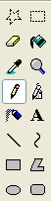 – left click mouse then draw.
3) Erase the drawing.
Ans;-Click on erase tool - left click & more erase.
4) Open the new blank page .Ans;- File – new.
5)Draw the drawing using shape in toolbar.
Ans:- Line , curve , rectangle, polygon , ellipse, rounded rectangle
6) Fill in the color in shape/drawing.
Ans:-Click fill color tools – choose color in color tools (click) – click in shape or drawing
7) Use flowing tools.
Ans:- (i) Air Brush : Clicking move cursor .
(ii) Pick color:Click the area containing the color you went to copy.
(iii) Text: Write the text (change from size /font)
(iv) Brush: To paint, drag the painter over the image (clicking).
(v) Magnifier: Zoom the image.
(vi) Free from select:click and select object freedom area.
(vii) Select: select the object rectangle area.
8) Save the file. Ans:- File – save.
9) Set the picture as background.
Ans:-File – set as background (Tiled)/set as back ground (center)
10) Close the ms paint.
Ans:-File – exit.

LESSION:- 3

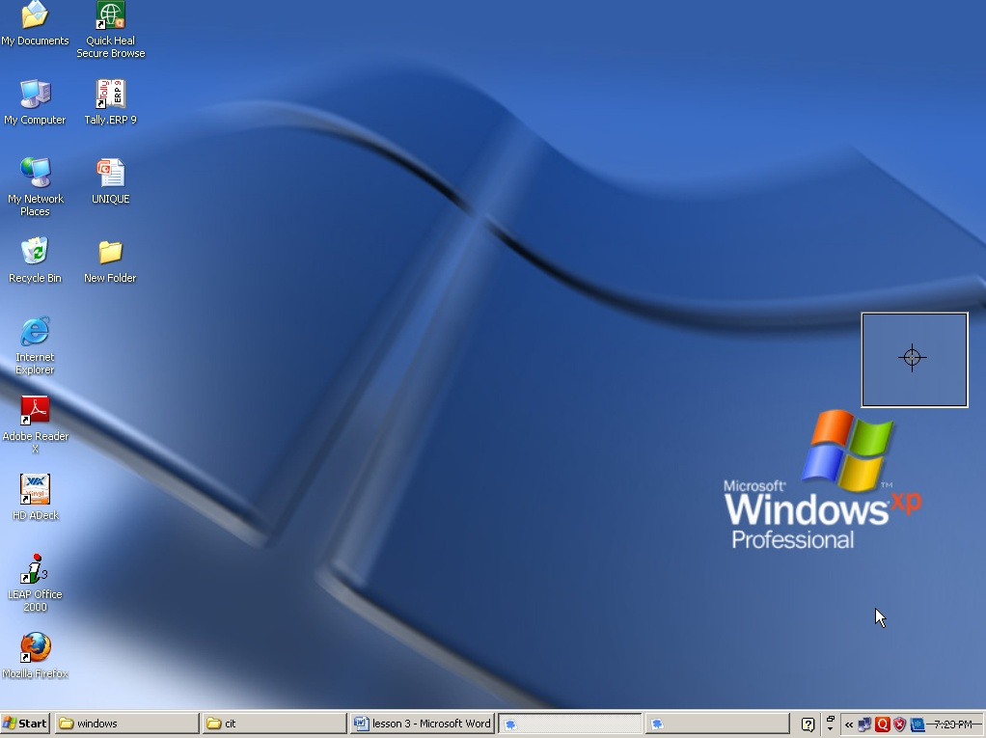
Desktop
Icon

Date & Time
Start Button
Taskbar or Active Program

- Create a Folder. Ans: - Right click-New-Folder-Type name-click outside.
- Create a File. Ans: - right click-New-text document-type name-click outside.
- Open the File. Ans: - Right click on folder/file-open.
- Delete the File or Folder. Ans: - Right click on folder/file-delete.
- Restore the Delete item.
Ans: - Open Recycle bin-Right click folder/file-Restore.
- Permanent delete. Ans: - Open Recycle bin –Right click on folder/file-Delete.

LESSION:- 4
- To rename the folder/file.
Ans: Right click on the folder/file-Rename.
- Open my document change Appearance of item.
Ans: Open my document –Right click (Blank area)-view (standard Toolbar) -choose Large, small list detail, Thumbnails.
- Arrange icon or Folder.
Ans: Right click-Arrange icon-choose.(Name, type, Size, Auto, Arrange)
- Copy the folder
Ans - Right click on the file/folder-copy-target-Right click-paste.
- Move the folder/file
Ans:-Right click on the folder-cut-Target-Right click-paste.
- Search the file or folder
Ans: Start-search-choose search type (Name) click search.
- Change Background Picture in Desktop?
Ans: Right click on the blank Desktop-properties – Background/Desktop-choose picture-apply-ok
- Set screen saver.
Ans: Right click on Blank desktop-properties- screen saver-choose the screen saver – set the time –Apply-ok. Type the name -3D Text-setting.
- Close the Computer.
Ans: - Go to start button- click on shut down option. (Restart, Stand by)

WordPad
Toolbar
LESSION:- 5
Ruler
Minimize, Restore, Close
Title bar

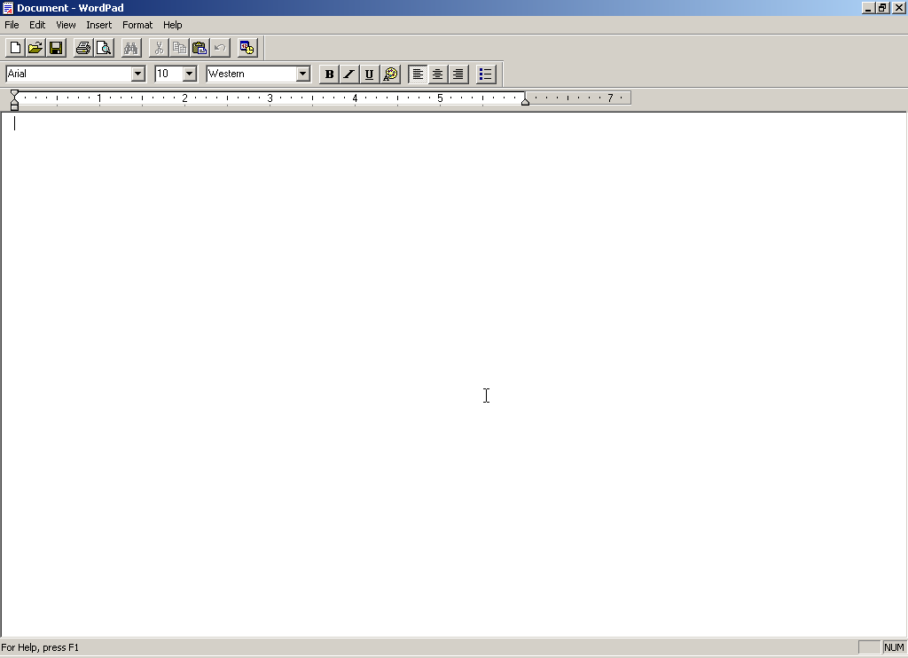
Format bar
Status Bar
Blank Page
1) Start WordPad. Ans: - Start –All Program – accessories – word pad.
2) Type the text (minimum 15 lines in 15 min)
Ans:- The quick brown fox jumps over the lazy dog.
3) Save the file. Ans:- Word pad – save – write the name – save.
4) Open the blank document. Ans: - Word pad – new – ok.
5) Open the save file. Ans: - word pad – open – type the name – open
6) Copy paste 3 times selected text.
Ans:- Select the text – Go to home tab - Clipboard Group – copy – position the cursor – past.
7) Move the text.
Ans:-Select the text – Go to home tab - Clipboard Group – cut – position the cursor – past
8) Exit the word pad. Ans:-Word pad – exit.
LESSION:- 6

1) Type the text (minimum 15 lines in 15 min).
2) Selected text bold italic under line.
Ans:- Select the text – Go to the Home Tab – font group- Click B for bold, I for italic, U for underline.
3) Chang font, font color & font size.
Ans:- Select the text – Go to the Home Tab – font group – choose font style – Change the font , font size & choose color – ok
4) Heading center bold, italic, under line.
Ans:- Select the heading text – Go to the Home Tab – font group - bold , italic , underline – ok . or Select Heading – Click B, I ,and U
5) We go to any mistake and go to back.
Ans:- Quick access toolbar – undo (ctrl+z)
6) Search the word has.
Ans:- cursor position beginning the paragraph - Go to the Home Tab – editing group – find- type the text(word) which find – click Find next
7) Replace the word “has” with “have”.
Ans:- cursor position beginning the paragraph – Go to the Home Tab – editing group – replace –
Find what……………………
Replace with …………………… - click replace/ replace all.
8) Set paragraph left 1”, right 0.5”, first line 0.5”
Ans:- select the text - Go to the Home Tab - paragraph group – set paragraph as per required - ok .

Microsoft Word 2007
LESSION:- -7
- Start the Microsoft office 2007.
Ans – Click on start button– All Programs – Microsoft office - Microsoft office word 2007.
- Micro soft word 2007 screen over view.
- Title bar (b) Office button (c) Quick access toolbar (d) Ribbon
- Type the text.
Ans – The quick brown fox jumps over the lazy dog.

- To save the file.
Ans – Click on office button – Save – Type file name – save.
- Open the blank document.
Ans – Click office button – New – blank documents – Create.
[Note – Also use Installed template & template]
- Close the file.
Ans – Office start button – Close.
- To open the save file.
Ans – Click office button – open – type file name – (Choose file location) – Open.
- To change the file name.
Ans – Click on office button – Save as – Choose Word document – Chang Location & file name – save.
- Copy, Paste the select text three times.
Ans – Select the text – Click on Home tab – Click on copy (Clipboard group) or ctrl+c – Position the cursor – click paste (Home Clipboard group) or ctrl+v. (Three time)
- Move the text from one place to another place.
Ans – Select the text – Click on Home tab – cut (Clipboard group) – Position the cursor – Click
Paste (Home tab – Clipboard group) (CTRL+V)

LESSION:- 8
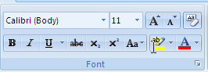

- To change the Font & Font Size.
Ans: - Select the text – Click on Home –[FONT GROUP] Choose Font & Change font size .
- Use the Bold, Italic, Underline & Strikethrough.
Ans:- Select the text – Click on Home – [FONT GROUP] - Click Bold, italic, Underline and see the effect.
- How to use Clear Formatting.
Ans:- Select the text (Remove the Formatting ) – Click Home – Click Clear Formatting in font group.
- Type the a²b².
Ans:- Select the 2 (only) – Click Home Super script [FONT GROUP]
- Type H₂SO₄
Ans:- Select the 2 (only) – Click Home-subscript [FONT GROUP]
- Highlight the text.
Ans:- Select the text – Home – Click text Highlight Color button – Choose color [FONT GROUP].

- Change the Font Color.
Ans :- Select the text – Home – Click Font color button – Choose color [FONT GROUP].
8) Type the Heading UPPERCASE.
Ans- Select the Heading - Click on Home –[FONT GROUP]- Click Change Case And choose UPPERCASE.
Note- UPPERCASE, lowercase, Title Case, Sentence case, tOGGLE cASE

LESSION:- 9

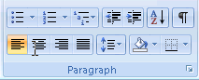
- Type the Five students name & Insert Bullets.
Ans :- Select the student name – Home – Click on Bullet List – Choose bullet [PARAGRAPH GROUP]
- Type the Five student name &Numbering.
Ans :- Select the student name – Click Home – Click on Numbering list – Choose Numbering Style.
- Change the Paragraph alignment.
Ans :- Select the text – Click on home – Choose a alignment left, right, center, justify in paragraph Group.
- Who to change the spacing between lines of the text.
Ans :- Select the paragraph – Click on line spacing tab – Choose the spacing.
- Create the paragraph border and shading.
Ans :- Select the paragraph – Click on paragraph Group – Choose Border and choose shading color.
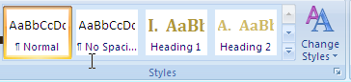
- To change the style.
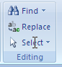
Ans :- Select the paragraph – go to home tab – Choose style [style group]

- Find and replace the word.
Ans :- Click home – Find (Editing Home ) – Find word …….. – Click on Find.
Click home – Find (Editing Home) – Replace …….. – Click on Replace.

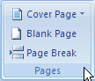
LESSION:- 10
- How to choose cover page design.
Ans – Click on insert tab – click cover page button & choose [Page Group]
- Break the page.
Ans – Click on insert – Page group – Page break
- Create a table 5 row and 6 columns. Ans – Insert – Table – table – move mouse point 5 row and 6 column (appear table in page) Or Click insert table – Type number of column – 6, Type number of row – 5 - Ok
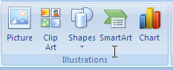
- Insert picture in the page.
Ans – Insert – illustrations Group – Picture – Choose picture in my Computer – insert.

- Insert clipart in the documents.
Ans – Insert – illustrations Group – Clipart – Type in search for ………. Go – Choose & Click on clipart.
- Insert Shapes in documents.
Ans – Insert – illustrations Group – Shapes – Click on shapes – click and drag in page.

- How to change line & fill color in shapes.
Ans – Select the Shapes – Drawing tools – Format – Shape style group – change fill color and line
Color or choose ready fill or line color.
- Choose the Shape or Picture position in page.
Ans – Select the shape or picture – Drawing tools – format – Arrange group – Choose position or
Choose bring to font, send to back or text wrapping.

LESSION:- 11

- Create heading & footer in document?
Ans:- click on insert –header & footer group – click header – header style or edit header or remove header(type the header)
Header & footer

Design
Click on go to footer – type footer – click on page number – choose page no. style. - Close header & footer.
- Insert text box in document?
Ans:-click on insert- text group- click text box – choose text box style or draw text box.
- Insert the word art?
Ans:- insert - text group – click word art – choose word art style – type the text – ok.
- Create four line drop cap?
Ans:- select the text – insert -text group – click on drop cape option – choose dropped or in margin – choose line to drop =4 – ok.
- Insert date & time.
Ans:- Insert – text group – click date & time- choose date & time – choose date & time format – ok.
- Insert symbol.
Ans: -Insert - symbol group- symbol – choose – symbol. - insert
Note: - For extra symbol choose web dings, wingding 2

LESSION:- 12
- To set the page margin.
Ans:- Select the text – Click on page Layout-(page setup Group)-margin – choose normal, narrow, moderate or choose custom margins- Margin -Type Top, left, Bottom Right –ok
- Change the page Orientation.
Ans :- Click page Layout –(page setup Group)- Click orientation and choose portrait or Landscape.
- Change the paper Size.
Ans :- Change page Layout (page setup group)- Click size – choose paper size.
- Split the text into two or more columns.
Ans:- select the text – page Layout( page setup group) click columns and choose two, three or more columns.
- Add line number in the margin of each line of the document.
Ans:- Page Layout-(page setup group) – Click line number – choose continues.
- Insert ghosted (watermark) text behind the content on the page.
Ans:- Page Layout-(page Background)- Watermark choose Watermarks or click custom watermark-picture watermark-select picture text watermark-language – text-type text- choose colour- apply-ok.
- How to choose a background color of the page.
Ans:- page layout-(page Background)- click page color- choose color.
- Insert page Borders.
Ans:- page layout-(page Background)- page Borders- choose Box-Line style, color, width-ok or click art-choose-ok

LESSION:- 13
(1)Check the spelling and grammar of the text.
Ans- Click the review – proofing group – spelling & grammar – check the change or ignore.

(2)Change the Document view.
Ans – View – document view – choose print layout, Full Screen Reading, Web layout, Outline, Draft.
(3)Show or Hide the ruler, Gridlines, Navigation
Ans – View – Click Ruler (Show/Hide), Gridline, Navigation
(4)Zoom the page.
Ans – View – Zoom group – Click zoom – choose zoom percent – ok.
View – Zoom group – 100%
View – One page
View – Two page
View – Window –
New Windows: Open the new window containing a view of the current document.
Arrange All: Tile all open program windows side by side on the screen.
Split: - splits the current window into two parts.
Switch Windows: - switch to a different currently open window.

LESSION:- 14

Microsoft Excel 2007

Excel- Microsoft Excel is a Spread sheet program. Which Allow one to enter numerical values are data into the row are column of a spread sheet and to use this numerical for such thing as calculation graphs and statistical analysis.

Cell- The intersection point between row and columns is called cell.

Cell Reference - The address of cell is called cell Reference.

Note- in Excel there are 16384, Column are 1048576, Column are labeled as A,B,C, D............. row are labeled 1,2,3,4...............,

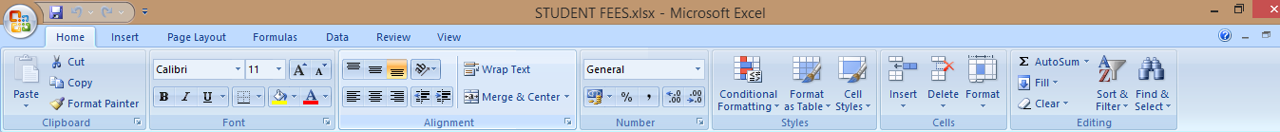

Table
1) Name Father Name Address Phone no Paid Amount

LESSION:- 15

- Fill from Monday to Sunday by dragging process.
Ans:- Write the day Monday – Select it- then dragging cursor to line and see the arrow then dragging.
- Write the table 2 to 10 using by dragging cursor.
Ans:- Write 2-Go to next cell write 4 select them then dragging cursor.

- Create a table.
City Nokia Samsung Lg Sony Total
Durgapur 50 70 20 10
Asansol 45 85 15 12
Raniganj 60 74 20 17
Pandaveswar 25 45 5 2
Haripur 45 80 9 4
Burdwan 100 180 56 25
Dubrajpur 45 68 45 15
Suri 49 70 6 5
Total
Ans:- Calculate the total of each City and item
Click on total cell –Write formula

=Sum(range) Enter
=Sum(B2:E2)
Select the number – Click on auto sum (Home tab- Editing Group)

LESSION:- 16

1. Create a table.
A | B | C | D | E | F | G | H | I | J | K | L
1 | Item | Jan | Feb | Mar | Apr | May | Total | Price | Amount | Exp. | P&l
2 | Fan | 15 | 25 | 24 | 75 | 24 |  | 80 |  | 5000
3 | Ram | 21 | 32 | 35 | 24 | 05 |  | 120 |  | 8000
4 | Hdd | 23 | 36 | 21 | 21 | 06 |  | 345 |  | 10000
5 | Motherboard | 20 | 54 | 24 | 23 | 58 |  | 289 |  | 15000
6 | Smps | 50 | 57 | 24 | 01 | 25 |  | 500 |  | 17000
7 | Processor | 25 | 65 | 35 | 02 | 12 |  | 800 |  | 9000
- Insert a column before item.
Ans- Click on home (Tab)-Go to cell group-click on insert-insert sheet Column.

- Insert a row for Heading “Unique Computer”.
Ans- Click on home tab-go to cell group-insert-insert-insert sheet row.
Note. Go to alignment group- Click on merge and center icon.
- Calculate Amount.
Ans- =total x price (=h2*I2)
- Calculate profit and loss.
Ans - Amount-Expenses (=J2-K2)
3) Auto format the table.
Ans. Select the table-Go to home tab-styles-format as table-Choose table styles-Ok.
4) Protect the work sheet.
Ans:- Go to review tab – change group-Protect sheet (click on)- type the password-ok-Type the Renter same password-ok.
5) Go to directly any specific.
Ans. Press - F5 - Write the cell Address - ok.
or
CTRL+G- Write the cell no-ok.

LESSION:- 17

1. Create a table

1 | A | B |  | C | D |  | E | F |  |  | G
1 | Name |  | Dept. | Basic |  | H.R.A | T.A |  | D.A | Salary
2 | A.Roy |  | Acct | 5700
3 | P.sen |  | MKT | 9000
4 | R.Kumar |  | Sale | 11000
5 | M.Singh |  | MKT | 3000
6 | L.Mukherjee |  | Acct | 5000
7 | S.Yadav |  | Sale | 7200

- Calculate the H.R.A (5% Of Basic) =Basic*5/100 =C2*5/100
- Calculate the T.A.(4% Of Basic) =Basic*4/100 =C2*4/100
- Calculate The D.A =Basic*8/100 =C2*8/100
- Calculate Salary
Ans:- =Basic + H.R.A + T.A +D.A (ENTER)
= Sum (Range from Basic to D.A)

2) Sort the data by Dept.(A) then by salary (B)
Ans:- Select the table – data(tab) –Sort and filter(Group) –click on (Dept) - click –add level -Then by (Salary) - ok.

3) Calculate Subtotal by each Dept.
Ans:- After Sort the table- select the table- data(tab) –out line (group)- Subtotal- ok.
Chang in- Dept.
Function – Sum

4) Calculate a chart or graph, Dept, Basic and given title.
Ans:- Select the Dept. and basic – insert (tab) – Chart (group) – Choose Chart- Ok.

LESSION:- 18

A | B |  | C |  | D |  | E |  | F |  | G |  | H
Name |  | Hindi |  | English |  | Math |  | Science |  | Total |  | Avg. |  | Remark
A.roy
P.sen
R.kumar
S.singh
L.mukherjee
S.yadav

- Calculate total marks. =sum(B2:E2)
- Calculate Average. = Average(B2:E2) or =Total/4

- Calculate Remark. (average >= 60 then 1st , Average >= 45, 2nd , Average >= 30 Pass otherwise Fail
Ans:- =if(G2>=60,”1st ”,if(G2>=45,”2nd”,if(G2>=30,”Pass”,if(G2<30,”fail”)))) Press Enter
- Find Highest & Lowest Marks.
Ans:- Formula tabs – function library group-more function-statistical-Max/Min-Rang the subject-Ok.
Or =Max(B2:E2)
=Min(B2:E2)
- Display whose total is >=300<=350
Ans:- select the heading-data tab-sort & filter group-click on total point-number effect-custom filter.

300
>or equal
To

350
<or equal
To

LESSION:- 19
Microsoft PowerPoint
MS Power point is used for creating graphic Presentation on a specific topic .Ms Power point is a package of MS office suite. A presentation consists of a group of slides that are shown in a particular sequence to the audience.
- How to create a Presentation?
Ans- we can create a new presentation by two ways:-
A) Template
B) Blank Slide
- How to create a new presentation from a blank Slide?
Ans- Click on MS OFFICE BUTTON –New –Blank Presentation –Create.
To type the Title of a Presentation click on – “Click to add title”
To type subtitle. Click to add subtitle and type.
- Change the size, Color, Font of the text.
Ans - Select the text Click Home Tab then go to Font Group and Change the Font, color, Size of the text
- How to change the text into vertical text and rotate the text?
Ans- Select the text then go to paragraph group then from the text direction chooses vertical rotate all text 90 degree.
- How to get a new Slide after the first Slide?
Ans - Click on Home Tab – New Slide –Office Theme -Choose a Slide.
- How to change the layout of Slide?
Ans- Click on Home Tab –Slide group –Layout option –Choose a Layout.
- How to delete a Slide?
Ans –From the Slide pan- select the slide then go to Slides group –Delete

LESSION:- 20
- How to insert picture in your slide?
Ans- Click on Insert Tab – Picture – From Insert Picture Window – Choose a Picture – clicks on Insert.
- How to apply shadow to the Picture?
Ans- Select the Picture – go to Picture styles Group – picture effects – shadow – perspective.
- How to put picture into any shape?
Ans- select the picture – Format – Picture style group – picture shape – From Basic Shapes – Choose a Shape.

- How to change the color mode and Variations of the picture?
Ans- select the picture – click Format Tab – go to – Adjust group - click on Recolor – From the color modes – and Variations – Adjust the color.
- How to add word Art to Slide?
Ans- click on Insert Tab – From Text group – Word Art – choose a Fill Text – Then type your Text.

LESSION:- 21
- How to animate text?
Ans- select the text – click on Animations tab – From Animations group – Animate – choose Fly or wipe.
- How to apply timing to animated text?
Ans- First apply Animation to the text – Advance Slide – Automatically After box – set the time – 1 or 2 second.
- How to apply custom Animation to the text?
Ans- Select the text – Animation Tab – Animation group – custom Animation – from custom Animation Pan – Add effect – Entrance – Choose effect.
4) How to apply Motion path to the text?
Ans- select the text – Animation text – Animation Tab – custom Animation – From Custom Animation pan – Add Effect – Motion Paths – Draw Custom Path – scribble – A pencil will appear – draw with the pencil.
5) How to view the slide show?
Ans- Slide Show Tab – start slide show Group – From Beginning or press F5
6) How make a project of Unique Computer – and set setup slide show?
Ans- click on office button – New – New Presentation – From Recently used Templates – Choose contemporary Photo Album – Create – type text add effect - to all slide - timing one second – Finally click on slide show-From setup group - Set the slide show-Setup show – setup group – setup slide show – setup show dialogue box will appear –
Show slides – From 1 to 6 show options – click loop with mously – than ok.

MS Word (advance) LESSON -22
- How to insert Smart Art?
Ans- Click on insert tab – From Illustrations Group – Click on smart art – From Choose a smart art graphic dialogue box Choose smart art - ok – Insert picture and type text.
- Insert Hyperlink with the selected text ?
Ans - Select text – click on insert tab – From link Group – Hyperlink from insert Hyperlink dialogue box select the document – ok – selected text colour will be changed - Put the mouse pointer on the colour text Ctrl + mouse left click – click on yes.
3 ) How to remove Hyperlink?
Ans – Click on insert tab – link group- hyperlink click – remove link.
- How to use Bookmark ?
Ans -Select the text – click on insert tab – from link group – click on bookmark – type a bookmark name – add.
- How to see or locate the bookmark?
Ans - Click on insert tab – link group –click bookmark – select the bookmark name – Goto.
- How to delete bookmark?
Ans – Click on insert tab – link Group –Click bookmark – select the bookmark name – delete .

MS Word (advance) LESSON-23

- How to draw table with Pencil?
Ans- Insert tab – Table – Draw table – a pencil will appear – Draw table.
- How to modify the table?
Ans- Click on table – Design tab – choose table styles- choose pen color – from Draw border – choose width of the line choose style of the line –choose shading to fill the cell.
- How to convert text into table?
Ans -Write five student names in same line with coma, press enter put number below to each name with comma; - select all the text – go to insert – Table –convert text to table.
- Insert Row /Column to left or right in the table?
Ans - Right in the column cell –From drop down list – Insert – Insert columns to the left / Insert Colum to the right.
- Insert a Row below the name Row?
Ans -5) Right click on the name cell – go insert – chooses insert Row below.
- How to delete a Row /Column?
Ans -Right click on the cell – Delete cells – Choose any row columns, or cell-ok
- How to convert 2 or 3 cells into one cell.
Ans - Select the cells – layout tab – From Merge group to – Merge Cells.
- How to convert table into text?
- Ans - Select the table – Go to layout tab – From Data group – Click on Convert to text – Choose Commas - ok
MS Word (advance) LESSON-24

- How to insert basic Math Symbol?
Ans - Place the Cursor where you want to insert Math symbol – insert tab –From Symbols group – Equation –symbols group – From Math box – Choose a symbol.
- How to go to any page number?
Ans - First insert tab – Page brake – Brake the pages – Go to home – Editing Group – Click on Find – Then go to – choose page enter page number – click on go to.
3 ) How to sort the text ?
Ans - Select the text - Home tab –Paragraph Group – Click on sort button –Choose Ascending or Descending – ok.
4 ) How to insert auto correct?
Ans - Insert Tab – Symbols group – Symbol – More symbols – Auto correct- Write E.C.L in replace box and select plane text – Write Eastern Coal Field L.T.D in with box – Add – ok – close.
5 ) How to view auto correct ?
Ans - Type E.C.L Press Enter
6 ) How to delete Auto correct ?
Ans - Go to symbol - more symbol – Auto correct –Choose ECL – Press delete – then ok – close.

ADVANCE LESSON-25

<First Name> <Last Name>
<Address 1>
<Dist>
<Post>
Sub:- ………………………………………………………………………………………………………………………..
Dear Friend………………………………..
…………………………………………………………………………………………………………………………………………………………………………………………………………………………………………………………………………………………………………………………………………………………………………………………………………………………………………………………………………………………………………………………………………………………………………….
Ans:-Click Mailing –click start mail merge – letter- select Recipients-type new list –customize column-
Choose Field name and use delete(which not use)-ok-Type full information (5 Records) –ok-Type file name –save .Go to Letter –cursor position-click insert merge field and position one by one –Finish and merge choose edit Individual document or print document.

Advance Lesson -26

- Insert the word count?
Ans - Type the text – Go to review tab – Proofing group – Right side of the Translate button click on word count.
- Show the bookmark with the help of Cross reference?
Ans -First create a book mark – go to Insert tab – link group – cross reference – go to reference type – choose book mark- choose the name of book mark – press insert It will show the word on which book mark had been made – click on the word and you will go the book mark position.
- How to use format painter?
Ans - Select a line - Change the font –click clipboard group – choose format painter – again select another with format painter, Line it will convert into previous font.
4 ) How to combine two shapes ?
Ans -Draw two figures – select both the figure with control Key – go to format tab – arrange group –Choose group option.
Note – To remove the group select ungroup.
5 ) Send a picture behind of text .
Ans -Insert a picture in the page – go to format tab- Arrange group – Choose text wrapping- Behind the text.
6) How to Protect the Page?
Ans - Go to Review Tab – Protect Group- Restrict Editing-New box will open in the right side of the screen- go to Editing Restriction and click in to the box- choose filling in forms from drop down list-click on yes , Start Enforcing Protection-pass word box will open then type a password and again repeat the password then ok.
7) How to Remove the Password.
Ans - Go to review Tab - Protect group- choose Restrict Editing –new box will open on the right side of the screen –choose stop protection –type the password –ok.

ADVANCE MS EXCEL-27
1.Create a table.
NAME | DEPT | BASIC | H.R.A | SALARY | P/F | NET-SALARY
Ahana | ACCT | 5700
Prapti | SALE | 9000
Ruhan | MKT | 11000
Shalini | MKT | 3000
Manohar | ACCT | 5000
Labanya | SALE | 7200

- Calculate P/F.
Ans:- =if(Basic>10000,Basic*10/100,if(Basic>5000,Basic*7/100,if(Basic>3000,Basic*5/100,if(Basic>2000,Basic*2.5/100)))) (Enter)
2. Display the record who is working in Acct and Sale Dept. using by advance Filter.
Ans:- a)Create a main table (b) Criteria table (c) Create output table.
Select the table-Data (tab)-sort & filter (group)-Advance filter-list range-select the table-criteria range-select the criteria table-click on copy to another location-copy to – select the range of output.
3. Display the records who are working in MKT Dept. and Basic more than 5000
Ans:- Same as above but criteria.
DEPT | BASIC
MKT | >5000
4. Display the record who is working in MKT Dept.
Ans:- Same as above but criteria.
DEPT
<>MKT
5. Insert comment.
Ans:- Select the cell- Go to the review- comments-click on new comment-insert comment.

Excel Advance lesson -28

Name | Hindi | English | Math | Science | Total | Avg | Division
Mallika | 78 | 67 | 79 | 57
Nitin | 89 | 80 | 85 | 81
Akshara | 90 | 69 | 66 | 91
Niladri | 88 | 92 | 93 | 57
Komolini | 77 | 45 | 94 | 66
Poonam | 98 | 40 | 69 | 89
- Calculate Total Marks:-
- Calculate Average:-
Ans:- Total /4 Enter

C) Conditional Formatting:-
Ans:- Select the Numbers –Home Tab –Style Group –Conditional Formatting –Highlight Cell rules –Greater Then- Type 90 and select blue Text from with box –Again Go to Conditional Formatting –Highlight Cell rules –Less then- Type 50 and select RED TEXT from with box.- Again Go to Conditional Formatting –Highlight Cell rules –between - Type 70 and 80 select green fill with dark green text from with box.

D ) To Remove Conditional formatting :-
Ans :- Select the marks - Go to Editing group-Clear – Clear format.

- Data Validation :-

Ans:- Select the marks –Data validation –Data validation –settings –From Allow box choose -Whole Number-In DATA Choose –Between –In Minimum box type -40 and in Maximum box type -99 Then click on Input Message –In the title box type School Marks class –v –In Input Message box-Type put marks between 40 to 99 – CLICK ON ERROR ALERT –From style box choose Warning-in title box type Wrong input number –In error message box type TRY AGAIN –Ok .

- Remove Data validation ;-

Ans:- Select the marks –Data – Data validation –CLEAR ALL.

G) FORM:-
Ans :- From Office Button –Choose Excel Option – Click on Customize – Choose all commands –click
On Form –Click Add –ok –Form option will appear in the quick access tool bar select the table –Go to form option –ok-Choose the name which you want to delete from the record click on delete option ok .
To add a new record click on new type the name put the number press enter.

H) Group :-

Ans:- Select the name and the marks- Data –Outline group –group-columns –Click on the Minus sign (-) button which has been displayed on the top to fold the table – to unfold click on ( +) SIGN .
- Ungroup :- Select the name and the marks- Data –Outline group –ungroup-columns –ok

 | EXCEL PROJECT 1
 | EMP NAME | AREA CODE | BASIC | TA | DA | GROSS SALARY | %TO PF CHARGED ON GS | %TO ITCHARGED ON GS | NET SALARY
 | KALYAN | RNG/01 | 4500 | CONDITION IF BASIC>=6000,RS.500 AND BASIC>=  5000,RS.400 ANDBASIC>=4500,RS.200 AND BELOW THAN 4500 NOT ALLOWED | CONDITION IF BASIC>=6000,RS.300 AND BASIC>=5000,RS.200 AND BASIC>=4500,RS.100 AND BELOW THAN 4500 NOT ALLOWED | BASIC+TA+DA | 2.30% | 1.20% | GROSS SALARY-PF-IT
 | SUBHADEEP | DRG/01 | 4800 |  |  | BASIC+TA+DA | 2.30% | 1.20% | GROSS SALARY-PF-IT
 | SABYASACHI | ASN/01 | 4200 |  |  | BASIC+TA+DA | 2.30% | 1.20% | GROSS SALARY-PF-IT
 | ALAUDDIN | RNG/02 | 5400 |  |  | BASIC+TA+DA | 2.30% | 1.20% | GROSS SALARY-PF-IT
 | ROHIM | RNG/02 | 5700 |  |  | BASIC+TA+DA | 2.30% | 1.20% | GROSS SALARY-PF-IT
 | PRITAM | DRG/01 | 6500 |  |  | BASIC+TA+DA | 2.30% | 1.20% | GROSS SALARY-PF-IT
 | GULAM | DRG/01 | 6400 |  |  | BASIC+TA+DA | 2.30% | 1.20% | GROSS SALARY-PF-IT
 | REIHAN | ASN/01 | 4700 |  |  | BASIC+TA+DA | 2.30% | 1.20% | GROSS SALARY-PF-IT
 | AMISHA | BAN/01 | 6200 |  |  | BASIC+TA+DA | 2.30% | 1.20% | GROSS SALARY-PF-IT
 | ADITI | BAN/01 | 6000 |  |  | BASIC+TA+DA | 2.30% | 1.20% | GROSS SALARY-PF-IT
 | MRITYUNJOY | MG/01 | 4900 |  |  | BASIC+TA+DA | 2.30% | 1.20% | GROSS SALARY-PF-IT
 | SRISHAJIT | DRG/01 | 3500 |  |  | BASIC+TA+DA | 2.30% | 1.20% | GROSS SALARY-PF-IT
 | HIMEL | ASN/01 | 3550 |  |  | BASIC+TA+DA | 2.30% | 1.20% | GROSS SALARY-PF-IT
 | PRATIK | BAN/01 | 4350 |  |  | BASIC+TA+DA | 2.30% | 1.20% | GROSS SALARY-PF-IT
 | SOUMIK | BAN/01 | 4590 |  |  | BASIC+TA+DA | 2.30% | 1.20% | GROSS SALARY-PF-IT
 | AJOY | RNG/01 | 3800 |  |  | BASIC+TA+DA | 2.30% | 1.20% | GROSS SALARY-PF-IT

 | EXCEL PROJECT 2
 | STUDENT NAME | HINDI | ENGLISH | MATH | PHY | LIFE | TOTAL | AVG | DIVISION
 | KALYAN | 54 | 45 | 46 | 65 | 65 |  |  | NOTE-AVERAGE>=60% FIRST,AVG>=45% SECOND AVG>=33% THIRD,AVG<33%,FAIL.
 | SUBHADEEP | 56 | 65 | 54 | 68 | 68
 | SABYASACHI | 65 | 46 | 56 | 95 | 95
 | ALAUDDIN | 76 | 50 | 46 | 85 | 45
 | ROHIM | 75 | 62 | 43 | 75 | 35
 | PRITAM | 43 | 54 | 42 | 62 | 37
 | GULAM | 57 | 53 | 52 | 34 | 38
 | REIHAN | 87 | 48 | 33 | 38 | 92
 | AMISHA | 63 | 46 | 34 | 65 | 45
 | ADITI | 34 | 65 | 52 | 75 | 68
 | MRITYUNJOY | 32 | 55 | 67 | 69 | 46
 | SRISHAJIT | 57 | 45 | 45 | 25 | 58
 | HIMEL | 35 | 34 | 34 | 45 | 57
 | PRATIK | 76 | 45 | 44 | 68 | 51
 | SOUMIK | 75 | 56 | 55 | 54 | 53
 | AJOY | 45 | 75 | 68 | 58 | 95

 | A | B | C | D | E | F | G | H | I | J | K
1 | NAME | ROLL | MATH | ENG | HIN | HIS | SC | TOTAL | PER | DIV | MAXNO
2 | ROHAN | 1 | 65 | 70 | 67 | 50 | 60
3 | BAPPI | 2 | 56 | 60 | 67 | 45 | 58
4 | SOHEL | 3 | 25 | 45 | 62 | 45 | 55
5 | MUNNA | 4 | 28 | 73 | 34 | 36 | 32
6 | RAJA | 5 | 53 | 90 | 61 | 68 | 53
7 | ANNU | 6 | 50 | 56 | 80 | 24 | 75
8 | GUDDU | 7 | 52 | 88 | 62 | 75 | 85
9 | MOHAN | 8 | 52 | 47 | 53 | 63 | 21

EXCEL PROJECT -3

- Calculate the total number of each student.
Hint = Sum (C2 : G2 )
- Calculate the percent marks of total students. Hint = Average ( C2 :G2 )
- Calculate the Division of each student.
Hint = if ( I2 >=60,”1st“ ,if (I2>=45,”2nd”,if (I2>=33,”3rd”,if (I2 <33,”Fail”,))))
- Calculate the Maximum Marks of each student.
- Highlight marks whose number is <33 in bold with red color.
Hint =Select range, and go to conditional formatting.
- Highlight marks whose number is <33 in bold with red color.
Hint = Select range, and go to conditional formatting.
- Create chart A) Chart title = Final result. (USE COLUMN CHART)
B) X Axis = Student name
c) Y -Axis = Marks obtain
Hint= Select range A1 to G9
- Filter the students name whose total marks is > 250
Hint =Select field heading and use auto filter
- Copy the students whose Percentage is > 60
Hint = Select field heading and use advance filter.
- Create comment on maximum number greater than 80
Hint = for comment type “your marks is very good. You have won a package of scholarship”
- Auto Format the table.
Hint = select the (A1 to K9) and go to auto format option in format Menu.
- Short the name of each student in ascending order.
Hint= select the range (A1 to K9) and go to SORT in DATA menu.

EXCEL PROJECT – 4

R .K HOSPITAL
PATIENT | DEPT | WARD | ADMISSON | DISCHARGE | DAYS | ROOM  RENT | FEES | AMOUNT
Kaveri | Skin | Special | 1 – jan-99 | 10 –jan 99 |  |  | 1200
Arav | Eye | General | 1 – jan-99 | 5-jan-99 |  |  | 2100
Shekhar | Skin | General | 4-feb-99 | 5-feb-99 |  |  | 800
Madhuri | Nose | Special | 2- jan-99 | 2-march-99 |  |  | 900
Akshar | Ear | Special | 2- feb-99 | 2 –feb-99 |  |  | 1350
Govinda | Eye | General | 22 –feb-99 | 28 – feb-99 |  |  | 2500
Ridhan | Ear | General | 3- march-99 | 31-march-99 |  |  | 2000
Kavya | Ear | Special | 10- march-99 | 5- may-99 |  |  | 4150
Ash Ankana | Skin | Special | 18 –march-99 | 1-April-99 |  |  | 3100

- Calculate the number of days i.e (discharge- admission date)or =DATEDIF(ADMISSION,DISCHARGE,”D”)ENTER
- Calculate the room based on the ward
Ward | Room rent per day
Special | Rs 125
General | Rs 50
OR
=IF (C3=”SPECIAL”, 125*NO. OF DAYS, IF (C3=”GENERAL”, 50*NO. OF DAYS)) ENTER
- Amount = Room rent + Fees.
- Sort the database in the ascending order of department.
- Create a subtotal of fees collected from each department .Remove the subtotals.
- Using subtotal of fees collected from patients in each dept. Remove the subtotals.
- Using Auto filter display the record of General Ward.
- Using Data form deletes the record of Govinda.

MS Office Access 2007

MS Office Access 2007 is a database product of MS Office. The extension name of MS Office Access 2007 file is ––– .accdb

How to open Access –––
1) Start All Programs MS Office MS Office Access 2007.
2) Start Run MS Access Ok.

Table
Field

Name | Address | DOB | Salary | Phone
Sanjay Das | Suri | 05/09/80 | 15600 | 9851312578
Dilip Dey | Suri | 06/02/65 | 25800 | 9732456312
Ruma Roy | Sainthia | 04/08/73 | 16000 | 9434581236

Record
How to create new file –––
Office Button New Blank Database D Drive File Name Ok Create.

How to create Table –––
Create Menu Table Design

Name –– Text
Address –– Text
DOB –– Date/Time
Salary –– Currency
Mobile –– Text

Close Yes Table Name Ok No.

How to Edit Table –––
Open the Table Home Menu View Design View Change anything Close Yes.

How to create Query –––
Create Menu Query Design Select Table Name Add Close Select fields and drag it field area Criteria (“Suri”) Office Button Save Query Name Ok.

Field | Name | Address
Criteria |  | “Suri”

How to Edit Query –––
Open Query Home menu View Design view Change anything Office Button Save Close.

How to Create Forms –––
Select Table Create menu Form Choose Auto format Office Button Save Type Name Ok Close.

How to Create Report –––
Select Table Create Menu Report Wizard Choose Table Select all fields Next Next Next Next Next Type Report Name Finish.

OR,
Select Table Create menu Report Choose any Auto format Office Button Save.

ACCESS-29
- Create a student sheet on Access.
1)Student_Name Text
2)Roll_No Auto number
3)Course_Name Text
4)Course_Fee Number
5)Admission_Fee Number
6)January Number
7)February Number
8)March Number
9)April Number
10)May Number
11)June Number
12)Total_Paid Number
13)Remaining_Fee Number
FORMULA:-
Total_Paid=Admission_fee+January+February+March+April+May+June (Enter)
Remaining_Fee=Course_fee – Total_Paid (Enter)

ACCESS-30
- Create simple interest on Access.
1) Holder_ Name Text
2)A/C Number
3)Principle_Amount Number
4)Rate_of_Interest Number
5) Time Number
6)Total_Interest Number
7)Net_Amount Number
FORMULA: - Total_Interest=Principle_Amount*Rate_of_Interest*Time/100 (Enter)
Net_Amount=Principle_Amount+Total_Interest (Enter)

ACCESS-31
- Create a student sheet on Access.
1) Student Name Text
2) Roll Number Auto number
3) Math Number
4) Bengali Number
5) English Number
6) Science Number
7) Geography Number
8) History Number
9) Total Number
10) Average Number

FORMULA:- Total=Math+Bengali+English+Science+Geography+History (Enter)
Average=Total/6
Internet

• Fundamentals of Internet  • Website visiting  • Search engine (Google)  • Email ID/ Email Account create  • Email sending with attach file  • Free SMS send (160by2.com)  • Face book and Chat  • Check exam result  • Recruitment information  • Google Earth  • Song downloading  • Picture downloading | • Software download  • News Paper reading (Anandabazar)  • How to see a Product details  • Concept of Online examination  • Free Video/ Voice calling (Skype/ Google talk)  • Windows Updating  • Windows Defender Updating  • Antivirus Updating  • Online Shopping  • Online Recharge  • Train Enquiry  • Team Viewer

What is Internet –––
The Internet is the largest computer network in the world, connecting millions of computers. A network is a group of two or more computer systems linked together. The Internet carries an extensive range of information resources and services, such as the interlinked hyper text documents of the World Wide Web (www) and the infrastructure to support email.

There are three types of computer networks:-

1) LAN (Local Area Network) ––––
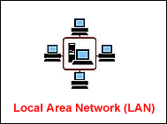
A LAN connects network devices over a relatively short distance. A networked office building, school, or home usually contains a single LAN, though sometimes one building will contain a few small LANs (perhaps one per room), and occasionally a LAN will span a group of nearby buildings.

2) WAN (Wide Area Network) ––––
A WAN is a geographically-dispersed collection of LANs. A network device called a router connects LANs to a WAN. In IP networking, the router maintains both a LAN address and a WAN address.

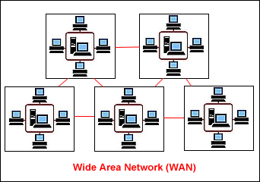

3) Other Area Networks ––––
i) WLAN (Wireless Local Area Network) ––– A LAN based on WiFi wireless network technology.

ii) MAN (Metropolitan Area Network) ––– A network spanning a physical area larger than a LAN but smaller than a WAN, such as a city. A MAN is typically owned an operated by a single entity such as a government body or large corporation.

iii) CAN (Campus Area Network) ––– A network spanning multiple LANs but smaller than a MAN, such as on a university or local business campus. Also known as Controller Area Network, or sometimes Cluster Area Network.

iv) SAN (Storage Area Network) ––– Connects servers to data storage devices through a technology like Fiber Channel.

v) SAN (System Area Network) ––– Links high-performance computers with high-speed connections in a cluster configuration. Also known as Cluster Area Network.

What is Webpage –––
Web pages are what make up the World Wide Web. These documents are written in HTML (hypertext markup language) and are translated by your Web browser. Web pages can either be static or dynamic. Static pages show the same content each time they are viewed. Dynamic pages have content that can change each time they are accessed. These pages are typically written in scripting languages such as PHP, Perl, ASP, or JSP. The scripts in the pages run functions on the server that return things like the date and time, and database information. All the information is returned as HTML code, so when the page gets to your browser, all the browser has to do is translate the HTML.

Please note that a Web page is not the same thing as a Web site. A Web site is a collection of pages. A Web page is an individual HTML document. This is a good distinction to know, as most techies have little tolerance for people who mix up the two terms.

What is Website –––
A website is a collection of web pages (documents that are accessed through the Internet). A web page is what you see on the screen when you type in a web address, click on a link, or put a query in a search engine. A web page can contain any type of information, and can include text, color, graphics, animation and sound.
Each Web site contains a home page, which is the first document users see when they enter the site. The site might also contain additional documents and files. Each site is owned and managed by an individual, company or organization.

Example ––– www.birbhum.gov.in, www.bmsuri.org, www.buruniv.ac.in www.lgindia.com etc.

What is web search engine –––
A web search engine is a software system that is designed to search for information on the World Wide Web. The information may be a specialist in web pages, images, information and other types of files.

Example ––– Google, Yahoo, MSN, Bing, Ask etc.

What is Internet or Web Browser –––

An internet/ web browser is the software application that we use to access the internet and view web pages on our computer. Browsers translates the basic HTML (Hypertext Mark Up Language) code that allows us to see images, text, videos and listen to audios on websites, along with hyperlinks that let us travel to different web pages.

Examples ––– Microsoft Internet Explorer, Mozilla Firefox, Opera, Apple Safari, Google chrome etc.

What is Email –––
Electronic mail or e-mail or email is text messages that may contain files, images, or other attachments sent through a network to a specified individual or group of individuals. The first e-mail was sent by Ray Tomlinson in 1971.

What is ISP (Internet Service Provider) –––

An Internet Service Provider (ISP) is a business or organization that offers users access to the Internet and related services. Many but not all ISPs are telephone companies or other telecommunication providers. The most common ways to connect to an ISP are by using a phone line (dial-up) or broadband connection (cable or DSL). Many ISPs provide additional services such as e-mail accounts, web browsers, and space for you to create a website.

Example ––– BSNL (Bharat Sanchar Nigam Limited), MTNL (Mahanagar Telephone Nigam Limited), Airtel, Vodafone, Reliance etc.

List Requirements needed to access Internet –––
i) A Computer ii) An Operating System iii) Internet Browser iv) ISP Plan v) Modem.

How to visit a Website –––
Open Internet Explorer/ Firefox Type Web Address/ Website in Address bar Enter Click in necessary Link.

Some website –––
www.anandabazar.com
www.birbhum.gov.in
www.bmsuri.org
www.buruniv.ac.in
www.lgindia.com

How to Search a website –––
Open www.google.com Burdwan University, India Enter Select Website of Burdwan University.

How to create Email ID/ Email Account –––
Sign up/ Create an account – to create New Email ID
Sign in – to enter Email ID
Sign out Logout – to exit from Email ID

www.gmail.com
www.yahoo.com
www.rediffmail.com
www.hotmail.com

Open www.gmail.com Create an Account Fill the form Next Step Next step Continue to Gmail Sign out.

How to send Email –––
Open www.gmail.com Enter Username Enter Password Sing in Compose/ New To (Type Email ID) Subject Type the message Click in Attach file Select a file Open Send.

How to send Free SMS –––
Open www.160by2.com Create an account Fill up the form Register Enter Mobile number Submit Type Mobile number and Password Change Password Logout.
• Open www.160by2.com Enter Mobile number and Password Login Send SMS Type message Enter Mobile number Send.

Face book ––– www.facebook.com
Exam Result ––– www.wbresult.nic.in
Google Earth ––– Open Google earth Type name of a place Enter.
Song downloading ––– www.indiamp3.com, www.bengali-mp3.com
Picture downloading ––– www.santabanta.com
Software downloading ––– Open www.google.com Type a Software name (MP3
Player) Enter Select a website.
News paper reading ––– www.anandabazar.com
How to see a product details ––– Open www.google.com Type a product name
(Samsung Tab) Enter Select a website.

Code Explanation
edu -------------- Educational facility
com -------------- Commercial organization
gov --------------- Government body
mil ---------------- Military concern
org --------------- Other organization
net --------------- Net work resource
ac ---------------- Academic institution
in ----------------- India
au ---------------- Australia
us ---------------- United States of America
uk ---------------- England

Abbreviations :-
Email – Electronic mail
IP – Internet Protocol
TCP – Transfer Control Protocol
HTTP – Hyper Text Transfer Protocol
FTP – File Transfer Protocol
SMTS – Simple Mail Transfer Protocol
DNS – Domain Name Server
WWW – World Wide Web
URL – Uniform Resource Locator
ISP – Internet Service Provider

