




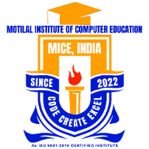
Limited Offer
- Short term Fun Learning Courses
- Diploma Courses
- PG Courses
- University Courses
- OKCL Courses
We provide courses as following below that enhance the digital knowledge of student that help to grow the carrier of student "To Lead Tomorrow."
https://themice.in
+91-7809 773 389
Enroll Now
100% job assistance and Guidance to student become successful.
Near Sc. College, Polasara, Ganjam, 761105
15% Discount
Interactive
& Engaging Learining
Study Well, Steady Learning
Learn Today
Lead Tomorrow

Motilal Institute of
Computer Education
CODE CREAT EXCEL
Our Courses :

